# DC-4E/GEDC-6E/AHRS-8 -- Application Note 1006

Software Release Firmware Upgrades with Flash Magic for the Sparton Inertial Systems.

*Introduction*

Sparton’s line of inertial systems are firmware updatable utilizing the Flash Magic application programming software. The instructions to perform the firmware upgrade are described in this document. If problems are encountered, check the Troubleshooting section at the end of this document.

The inertial sensor has two types of non-volatile memory: flash and EEPROM. The flash memory contains the unit’s firmware. The EEPROM memory contains three types of data.

* Data that has been modified at the factory as part of calibration
* User loaded NorthTek ™ scripts
* User Data (This includes User modified data and the user copy of calibration data)

In order to perform a clean firmware upgrade, it is necessary to first clear the user data sector of the EEPROM memory. If the user data sector of the EEPROM is not cleared there is a chance that, when the unit first boots up after the upgrade, that old EEPROM data will overwrite new data from the upgrade.

The factory cal data will not be affected by clearing the user data sector of the EEPROM. But as a precaution, the procedure will have the user save this data to a text file. This ensures the data will be available in the event that it is needed.

User loaded NorthTek ™ scripts will not be affected by clearing the user data sector of the EEPROM.

User modified data is lost when the user data sector of the EEPROM is cleared. Therefore, it is important that the user determine if there is any user modified data that needs to be preserved. The procedure below will describe how to save this user modified data prior to clearing the user data sector of the EEPROM and then restore it afterwards.

After extracting the user modified data as described in the procedure below, the user should inspect the data. Some variables may be identifiable as having been set by the user directly such as orientation and baud. Others may have been set indirectly by user action such as:

* boresightMatrixX, boresightMatrixY, boresightMatrixZ – reload these if the user ran the Tare.4th script, ran InvokeTare or set the boresightMatrix directly
* magvar, wmmGD, wmmHasRun – reload these if the user ran the World Magnetic Model (Auto Variance) or set magvar directly
* magFieldCalX, magFieldCalY, magFieldCalZ – reload these if the user ran the in-field calibration and the user expects that calibration to remain valid

# *Prerequisites*

* Flash Magic Host Application: Flash Magic can be downloaded for free from [www.flashmagictool.com](http://www.flashmagictool.com).
* Sensor mounted on an NDS-1 Adaptor Board or equivalent board
* Terminal emulator: NDS-1 Host Application v2.3.1 or later is recommended. Other applications may be used such as HyperTerminal or Tera Term Pro (http://ttssh2.sourceforge.jp/), etc. The unit’s default baud rate is 115200, but if the user has changed the unit’s baud rate then use that setting. Details for the setup of NDS-1 and Tera Term are in the reference section following the procedure section below. .
* NDS-1 Quick-Start Guide available for download at [spartonnavex.com](http://www.thedigitalcompass.com) .
* Text Editor: WordPad or Notepad++ recommended.
* Observe precautions for handling Electrostatic Sensitive Devices when handling Sparton inertial systems and the NDS-1 development board.

# *Procedure*

1. Prepare the NDS-1 adapter board (or equivalent)
   1. Refer to the “NDS-1 System Set Up” instructions in the "NDS-1 Quick-Start Guide"to mount the inertial sensor on the NDS-1 Adaptor Board. The NDS-1 Host Application is not needed for this procedure if the user has chosen to utilize another terminal emulator application.
   2. Remove power to the NDS-1 adaptor board.
   3. Set up the board for either RS232 or USB connection. Jumper P1 (labelled RS232):
      1. Short for RS232
      2. Open for USB.
   4. Power on the NDS-1 adaptor board.
2. Prepare to load the firmware into Flash memory
   1. Power off NDS-1 adapter board ( If using USB, disconnect the USB)
   2. Remove the shunt from pins 2 and 3 of the jumper P7 (labelled WREN)
   3. Short pins 1 and 2 of the jumper P3 (labelled RTS) and P4 (labelled DTR) with shunting plugs. To summarize:
      1. P3 (RTS): shorted
      2. P4 (DTR): shorted
      3. P7 (WREN): all 3 pins open
   4. Close any terminal emulator applications that may be utilizing the Com port. Disconnect the NDS-1 navigation development system host application (GUI) if it is connected.
   5. Power up NDS-1 adapter board (if using USB reconnect it now)
   6. Open the Flash Magic application
   7. Configure Flash Magic as shown below (except select the appropriate COM port and browse to the firmware hex file location):

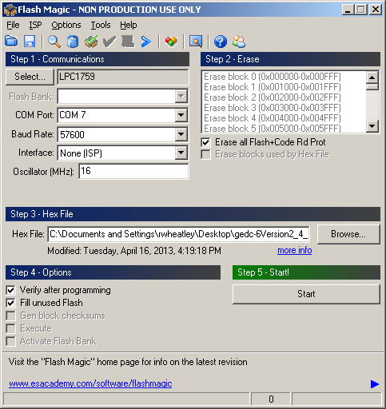

* 1. Select Options->Advanced Options…->Hardware Config, configure as shown below and click OK:

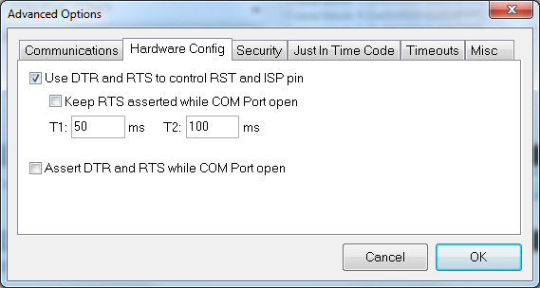

* 1. Click Start on the main Flash Magic page.
  2. Progress is shown in bottom left corner of Flash Magic page. The load process can take 5 or 10 minutes. When finished Flash Magic will display "Finished" instead of the progress indicator.

Note: "Finished" will only display for about 10 seconds, and then it will disappear. If the user misses seeing the word "Finished" it can be confusing as to whether the process completed properly. So if the lower left corner display is blank (like the first screen shot above) and there are no error messages, then the load process completed successfully.

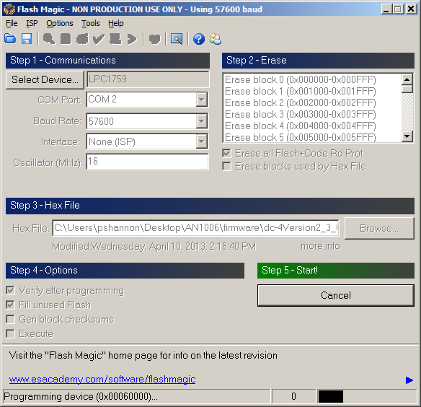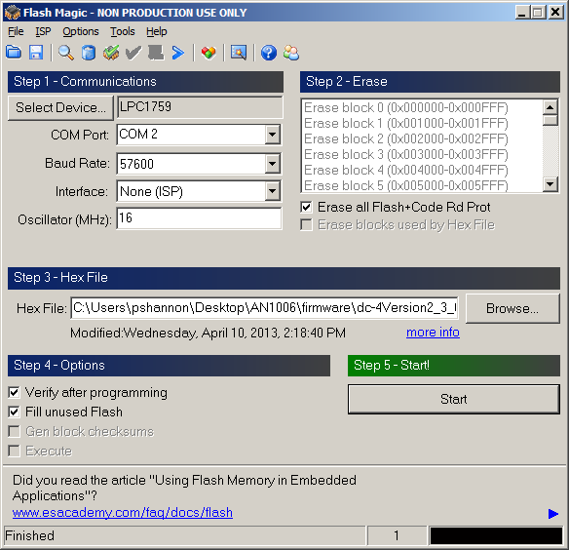

* 1. Close the Flash Magic application when done

1. Remove power from the NDS-1 adapter board
2. Remove P3 (RTS) and P4 (DTR) shunts (shorting plugs). To summarize:
   1. P3 (RTS): open
   2. P4 (DTR): open
   3. P7 (WREN): all 3 open
3. The software update is now complete

# *End of Procedure*

# Reference Information

# *NDS-1 Terminal Emulator Setup:*

The Com port connection will fail unless the port is connected to the dev board and the dev board is powered on. Select the appropriate Com port.

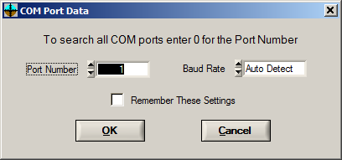

Drop down menu > Options > Terminal Emulator

Verify communication by typing Enter. The display returns "OK".

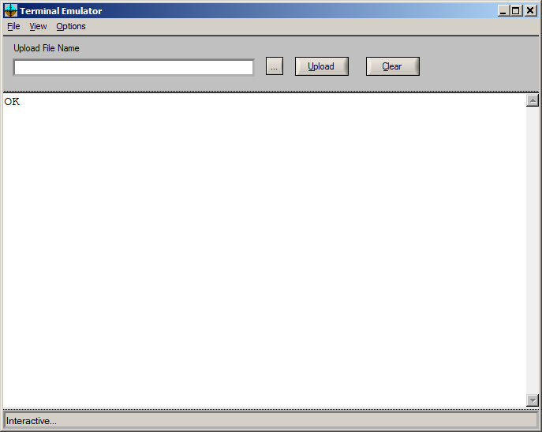

If it fails to connect, check the board jumper settings and make sure there is no other application holding the Com port.

# *Tera Term Setup:*

To set up Tera Term, install the product into a location chosen by the user. Open Tera Term to start a session. Go to ‘Setup’ and select ‘Serial Port’.

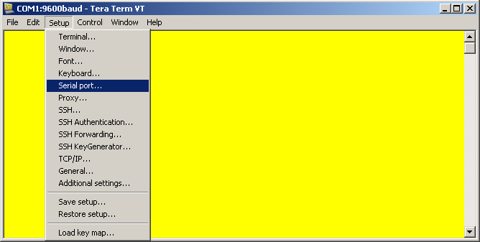

Figure 1 - Main Tera Term Window

Once the window in Figure 2 appears, select the appropriate baud rate for the product. Make sure the ‘Data’, ‘Parity’, ‘Stop’, ‘Flow control’, and ‘msec/line’ fields all match the values in the Figure 2.

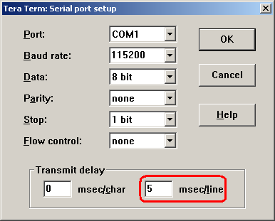

Figure 2 - Tera Term Serial port setup Window

# Go to ‘Setup’ and select ‘Terminal’.

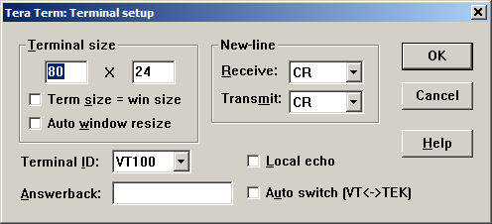

Figure 3 - Terminal Setup in Tera Term

# Troubleshooting:

# *Restoring User Modified Data:*

It is important that the file used to upload user modified data contains <CR><LF> after every line. Below is an example of a Notepad file without <CR><LF>s. This will not work.

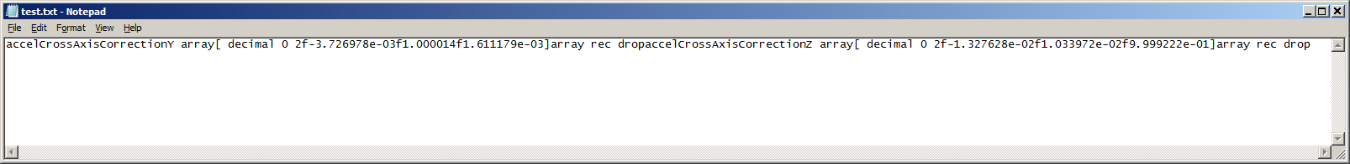

If a file like this is loaded, the terminal emulator will display "Huh ??" and subsequent commands in the terminal emulator may not function properly. In this case cycling power to the NDS-1 adaptor board and disconnecting/reconnecting the Com port connection in the terminal emulator should restore functionality.

Below is a screenshot of the same file opened and then saved in WordPad. It now has the <CR><LF> after every line. This file would successfully load.

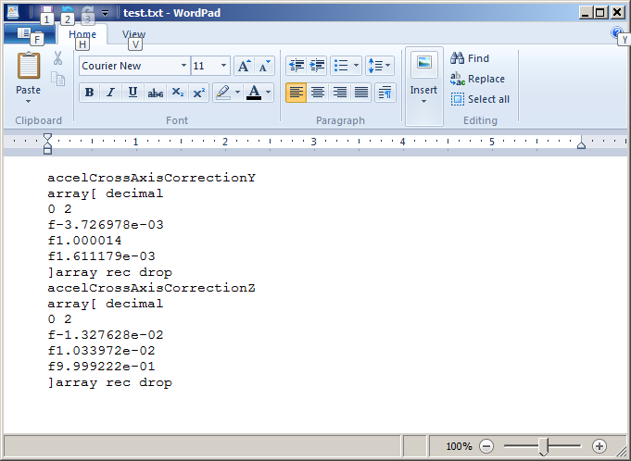

Notepad++ is useful to confirm the presence of the <CR ><LF>.

View > Show Symbol > Show End of Line

This is the same file opened in Notepad++.

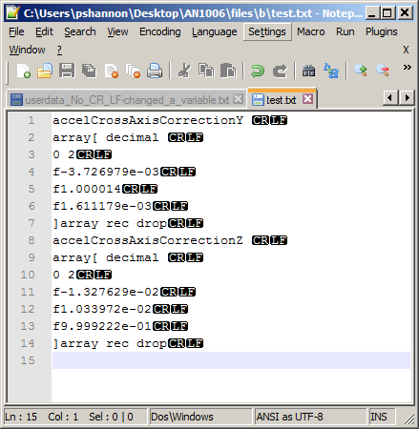

# Do not use MS Word as the text editor. Even though it has the <CR><LF>, the full text formatting of Word will cause problems. WordPad or Notepad++ work best.

If you see this message window, check the file before proceeding with the upload. It may contain unexpected data which will have to be deleted.

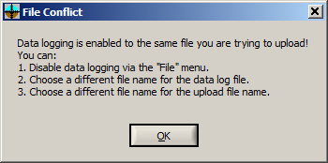

# *Flash Magic:*

If Flash Magic fails the load or verify, try reducing the baud rate.

If Flash Magic reports:

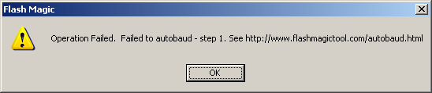

Check:

* Is the power on to NDS-1 adapter board?
* Is the NDS-1 adapter board configured correctly for the connection used (either RS232 or USB)?
* Are the P3 (RTS) and P4 (DTS) shunts (shorting plugs) installed?

**Want to know more?**

* Check it out here: [spartonnavex.com](http://www.thedigitalcompass.com)
* Questions or support issues can be directed to [productsupport@sparton.com](mailto:productsupport@sparton.com)